

**Progress Report 2：**

**User Interface Design**

**Team 14: GOSH: App for child growth charts in R**

**Rajan Hirani** rajan.hirani.17@ucl.ac.uk

**Saleh Khalil** saleh.khalil.17@ucl.ac.uk

**Sander Da Mata Miranda** sander.miranda.17@ucl.ac.uk

**COMP103P Applied Software Development**

**February 5, 2018**

Department of Computer Science

University College London

**Related Projects Review: (Growth Charts UK-WHO iOS App)**

The URL for this app is: <https://itunes.apple.com/gb/app/growth-charts-uk-who/id916579608?mt=8>

**Main Features:**

The main features of this iOS app are that you can calculate growth centiles for a child. You can calculate weight, height, head circumference and BMI centiles.

**Advantages:**

One advantage of this mobile application is that you can see the centile for each characteristic (weight, height, head circumference and BMI). Another advantage is that it tells you the z-score of the measurements so the user can see how much the measurement differs from the average value. The application is also user-friendly so it is for users to use the application.

**Disadvantages:**

A disadvantage of the mobile application is that you can’t see the corresponding measurement for each centile, the chart only shows the centile of the entered measurement. Another disadvantage is that the user can only enter one data point at a time so users can’t see how a child’s growth changes overtime. Also you can’t save any data that is inputted so this application is more useful when a user wants to check the centile measurement quickly rather than plotting the measurement on a paper based graph.

**Site Map:**

This is a general layout of how the application will be structured.

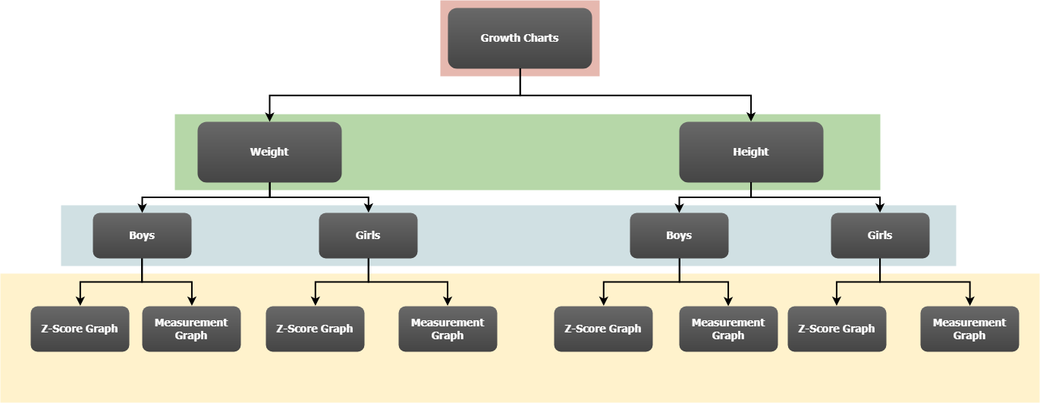

**Page Design:**

This is a general design for how one of the pages in the application will look like. The design may not be an exact replica of the final application but the key aspects will be the same (i.e. tabs and text format may change).

